FUNDAMENTALS OF DATA SCIENCE DSA – 0406

1) Average score for each subject and highest average
import numpy as np

student_scores = np.array([
[85, 78, 90, 75],
[92, 88, 85, 80],
[76, 82, 79, 88],
[89, 91, 87, 84]
])

subject_avg = np.mean(student_scores, axis=0)

subjects = ["Math", "Science", "English", "History"]

print("Average scores:")
for i in range(4):
print(subjects[i], ":", subject_avg[i])

highest_subject = subjects[np.argmax(subject_avg)]

print("Subject with highest average:", highest_subject)

Output:-
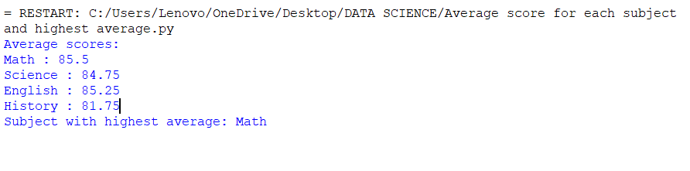

2) Average price of all products sold

import numpy as np

sales_data = np.array([
[100, 120, 150],
[200, 180, 220],
[50, 75, 80]
])

average_price = np.mean(sales_data)

print("Average price of all products:", average_price)

Output:-

3) Average sale price of Houses with More than 4 bedrooms
import numpy as np

house_data = np.array([
[3, 1500, 250000],
[5, 2200, 400000],
[4, 1800, 320000],
[6, 2500, 500000],
[7, 3000, 600000]
])

selected_houses = house_data[house_data[:, 0] > 4]

sale_prices = selected_houses[:, 2]

average_price = np.mean(sale_prices)

print("Average sale price:", average_price)

Output:-

4) Total annual sales and percentage increase

import numpy as np

sales_data = np.array([10000, 12000, 15000, 18000])

total_sales = np.sum(sales_data)

percentage_increase = ((sales_data[3] - sales_data[0])
/ sales_data[0]) * 100

print("Total sales for the year:", total_sales)
print("Percentage increase from Q1 to Q4:", percentage_increase, "%")

Output:-

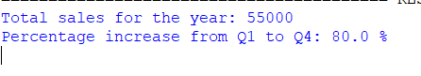

5) Average fuel efficiency and percentage improvement

import numpy as np

fuel_efficiency = np.array([25, 30, 35, 40, 45])

average_efficiency = np.mean(fuel_efficiency)

percentage_improvement = (
(fuel_efficiency[1] - fuel_efficiency[0])
/ fuel_efficiency[0]
) * 100

print("Average fuel efficiency:", average_efficiency, "MPG")
print("Percentage improvement:", percentage_improvement, "%")

Output:-
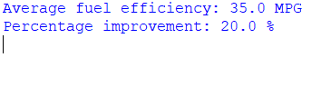
6) Total cost including discount and tax

prices = [100, 200, 150]
quantities = [2, 1, 3]

discount_rate = 10 # 10%
tax_rate = 5 # 5%

subtotal = sum(p * q for p, q in zip(prices, quantities))

discount = subtotal * discount_rate / 100

amount_after_discount = subtotal - discount

tax = amount_after_discount * tax_rate / 100

total_cost = amount_after_discount + tax

print("Subtotal:", subtotal)
print("Discount:", discount)
print("Tax:", tax)
print("Total cost:", total_cost)

Output:-
